Work Zone Photo Scavenger Hunt
There are many precautions taken in and around a work zone to keep road workers and you, the driver, safe. You likely often see them but may not notice them and their importance.
We hope this work zone scavenger hunt will help you better understand what it takes to keep everyone working in and traveling through a work zone safe.
Objective: Complete the Work Zone photo scavenger hunt
Submission: Your scavenger hunt results can be submitted two ways.
- Upload photos of each item (15 photos total)
- Upload 1 pdf/word document of all photos
IMPORTANT: Photos taken from inside a vehicle will not be accepted. Be safe!
Item | What does it look like? | Why is it important?
Arrow Board |  | Arrow boards provide additional warning and directional information to  assist in merging and controlling road users through or around a work zone. They tell you which way to go.
Message Board | 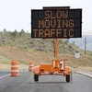 | The primary purpose of  Message Boards is to advise drivers of unexpected traffic and routing situations – things that are more complex than simply moving over or changing lanes
Traffic Cones | 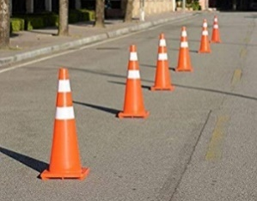 | Traffic cones are a type of “channelizing device” and are used to delineate the desired vehicle path, mark specific hazards on or near the roadway, separate opposing traffic flows, and  partially or totally close the roadway.
Construction Barrels | 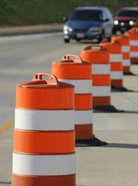 | Construction barrels are another type of “channelizing device”. This is what is most commonly used for longer-term highway work in TN.
Barricade | 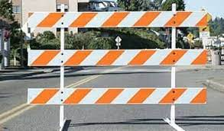 | Barricades are a type of channelizing device that are intended to communicate the end of a roadway or path in the work zone. They inform a road user that they cannot continue in the direction of the barricade. Stripes on barricade rails slope downward at an angle of 45 degrees in the direction road users are to pass. Drivers should go to the left of this example.
Guardrail | 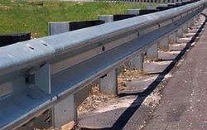 | A guardrail is, first and foremost, a safety barrier intended to shield a motorist who has left the roadway. They can make roads safer and lessen the severity of crashes.
Cable Barrier | 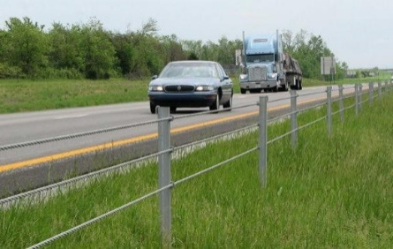 | A cable barrier is a type of roadside or median safety traffic barrier. It consists of steel wire ropes mounted on weak posts that are designed to break easily if struck. We use this in TN to help prevent cross-median crashes.
Flagger Symbolic Sign | 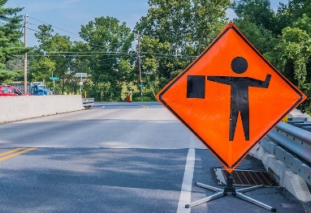 | This sign alerts motorists that there is an actual person controlling traffic up ahead. We should be especially alert when we see this sign.
Truck Mounted Crash Attenuator | 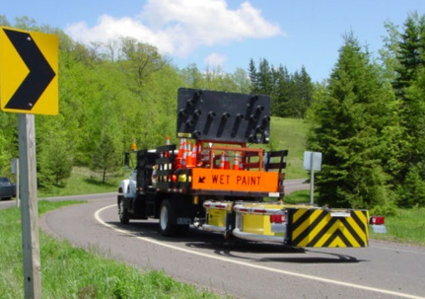 | Sometimes referred to as “crash cushions”, attenuators protect workers in the road. They also protect the occupants of a vehicle that crashes into them, as they are designed to absorb the energy of an impact. These attenuators are attached to large trucks.
Trailer Crash Attenuator | 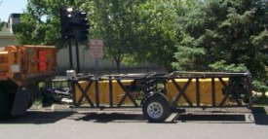 | Similarly, these types of attenuators perform the same life-saving task of protecting both workers and careless motorists; only they are towed behind another construction vehicle.
Vehicle Queue | 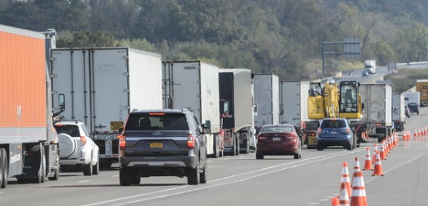 | Simply put, a “queue” is a line of backed-up traffic, due to road work, highway incidents, or too many vehicles for the roadway. The back of the queue can be particularly dangerous because traffic moving at highway speeds may have to come to a sudden stop.
Flagger with STOP/SLOW Paddle | 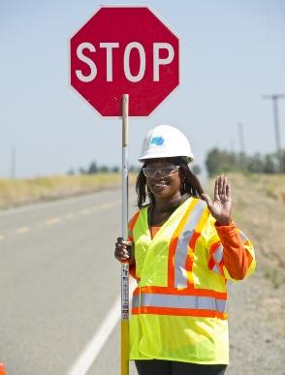 | Most flaggers use STOP/SLOW paddles instead of actual flags to control traffic in a work zone. The STOP sign is actually enforceable by law.
Road Work Crew |  | These are the real heroes who risk their lives every day to ensure that we all have a way to get to where we want to go.
Truck w/Stripes on Back | 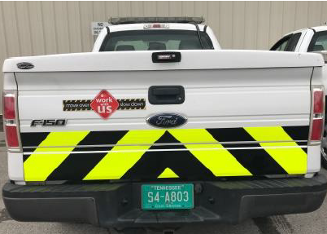 | These stripes are called “conspicuity markings” and they’re intended to make other motorists aware of a road worker’s vehicle. If you see them, remember to watch for sudden stops.
Road Worker Wearing Reflective Clothing | 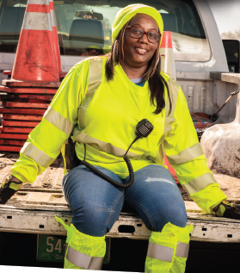 | Road workers wear special clothing to ensure that they can be seen at all times. The bright yellow stands out during the day, while the stripes are reflective at night.

